Aligning three measures of adult literacy and numeracy
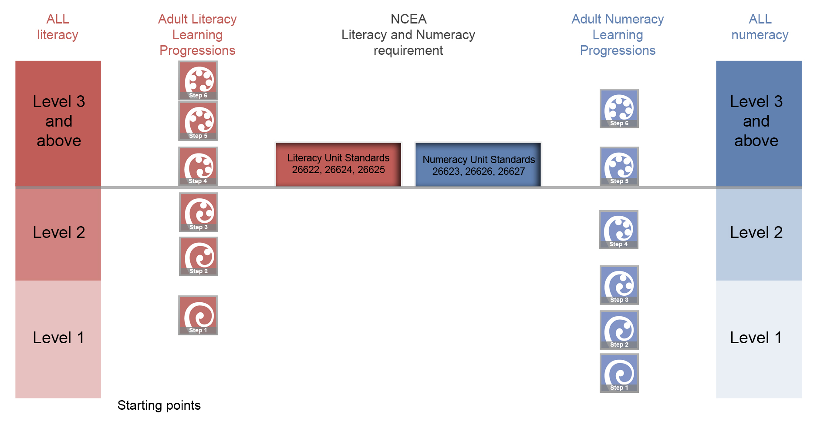
- Aligning Unit Standards, Adult learning progressions and ALL survey levels

Figure 1 illustrates how three different measures and descriptions of adult literacy and numeracy may relate. It is important to note that the measures were developed for different purposes and describe literacy and numeracy competencies in different ways. This information supersedes the previous alignment diagram found on http://literacyandnumeracyforadults.com/

- The literacy and numeracy unit standards are at level 1 on the New Zealand Qualifications Framework (NZQF). The New Zealand Qualifications Authority aligned the literacy unit standards (US26622, 26624 and 26625) to step 4 of the Adult Learning Progressions for reading, writing, listening and speaking. The numeracy unit standards (26623, 26626 and 26627) are aligned to step 5 of the Adult Learning Progressions for numeracy.

- The literacy and numeracy requirements for NCEA Level 1 are a minimum of 10 literacy credits and 10 numeracy credits obtained through either specified achievement standards or the package of three literacy and three numeracy unit standards described in 1 above. Note that the NCEA Level 1 Literacy and Numeracy requirement must be met to achieve the Level 2 NCEA qualification from 2013 and the Level 3 qualification from 2014.

- The learning progressions were developed as a set of continuums with each step along the continuum representing a significant learning development. Because of this the steps are uneven with some being closer together than others. The relative size of steps in the reading, writing and numeracy progressions was estimated as part of the calibration exercise conducted during development of the Literacy and Numeracy for Adults Assessment Tool. It needs to be noted that the scales for reading, writing and numeracy are independent of one another. This means, for example, that step 3 on writing is not equivalent to step 3 on reading or numeracy.

- The Adult Literacy and Life Skills Survey (ALL) was an international comparative assessment that provided information about the literacy and numeracy of the adults in the population aged 16 to 65 years-old. Level 3 is considered a suitable minimum for coping with the demands of everyday life and work in a complex, advanced society. ALL levels 1 and 2 can be defined as “low literacy and numeracy”; levels 3, 4 and 5 can be described as “higher literacy and numeracy”.

- The learning progressions and ALL describe and measure adult literacy and numeracy in different ways. It is estimated that a learner who has reached Step 4 on the reading progressions or Step 5 on the numeracy progressions would be very likely to be assessed at level 3 or higher on the ALL survey.

- Learner Assessment Tool reports that are recorded at step 5 for numeracy and step 4 for reading are acceptable as a piece of evidence towards the learner portfolio for the NCEA Literacy and Numeracy unit standards that are listed above.

The survey has been superseded by the Programme in International Assessment of Adult Competencies (PIAAC). The PIAAC survey will be run in New Zealand in 2014.
http://www.educationcounts.govt.nz/publications/series/ALL/56051/8
This is based on comparing the descriptors of the steps in the progressions with the levels in the ALL survey, as well as empirical data collected during the development of the assessment tool and comparing the ALL and Assessment Tool results of 91 ALL survey participants.

